Fashion Recommendation System

Başak TOPÇUOĞLU Arda ARSLAN Hakan Sertuğ ŞENER

Izmir Democracy University Izmir Democracy University Izmir Democracy University basaktopcuoglu4@gmail.com ardaarslanidu@gmail.com hakansertugsener@gmail.com

2006102061 2006102021 2106102039

# ABSTRACT

Our project offers an outfit recommendation system using deep learning and computer vision techniques. The system processes each collection of fashion images stored in a designated directory and extracts features from specific areas of interest, such as tops, using a pre-trained ResNet50 model. The features are then compared to a set of reference images representing various clothing categories, including T-shirts, pants, shoes, and accessories. Additionally, the code also includes face detection, which uses the MTCNN (Multi-Task Cascade Convolutional Networks) algorithm to exclude images containing faces, thus focusing on clothing items. The recommendation system calculates the similarity between extracted features and reference features using cosine similarity. The implemented system covers a wide range of clothing categories and offers recommendations for men's and women's clothing, shoes and accessories. The best recommendations for each category are presented based on the highest similarity rates. The code facilitates easy customization to expand the reference image dataset and supports adaptation of the recommendation system to various fashion domains. This clothing recommendation system can be a valuable tool for fashion enthusiasts, online retailers, and e-commerce platforms who want to improve user experience by recommending visually similar clothing items based on specific preferences and styles.

# KEYWORDS

Fashion recommendation, Recommendation system, CNN, User ratings, preferred combinations.

# INTRODUCTION

The primary objective of this comprehensive report is to furnish a detailed overview and thorough analysis of the sophisticated clothing recommendation system embedded within the supplied codebase. At its core, the system leverages cutting-edge deep learning methodologies and advanced similarity measures to deliver tailored recommendations for clothing items, primarily contingent on their distinctive visual features.

In a landscape inundated with an expansive array of fashion choices, consumers often find themselves grappling with the challenge of sifting through an overwhelming multitude of options. Recognizing this prevalent issue, the implemented clothing recommendation system seeks to streamline the decision-making process for users by harnessing the power of state-of-the-art artificial intelligence techniques. By delving into the intricate visual characteristics of clothing items, the system endeavors to provide insightful and personalized suggestions, thereby enhancing the overall shopping experience.

As we delve deeper into the subsequent sections of this report, we will unravel the intricacies of the codebase, shedding light on key functionalities, model architectures, and the underlying mechanisms that drive the system's ability to discern and recommend clothing items. Furthermore, a comprehensive exploration of the reference images and the recommendation process will be undertaken, elucidating the manner in which the system distills complex visual information to offer precise and relevant suggestions.

Code Overview

The code is written in Python and utilizes several libraries, including TensorFlow, Keras, MTCNN, and Matplotlib. The key functionalities of the code include:

• Mounting Google Drive to access image data.

• Installing necessary libraries (TensorFlow, MTCNN).

• Loading a pre-trained ResNet50 model for feature extraction.

• Utilizing MTCNN for face detection in images.

• Extracting clothing features from images.

• Calculating cosine similarity between clothing features for recommendation.

• Displaying reference and recommended images.

## Fashion Recommendation Related Works

• T. Iwata, S. Watanabe, and H. Sawada. Fashion coordinates recommender system using photographs from fashion magazines. In IJCAI, 2011

•

• V. Jagadeesh, R. Piramuthu, A. Bhardwaj, W. Di, and N. Sundaresan. Large scale visual recommendations from street fashion images. In KDD, 2014.

1.2 Model and Feature Extraction

## Our code uses the ResNet50 model pre-trained on ImageNet to extract features from clothing images. Features are extracted from the top part of the image, assuming it includes the clothing area. We used MTCNN for face detection and excluding images containing faces.

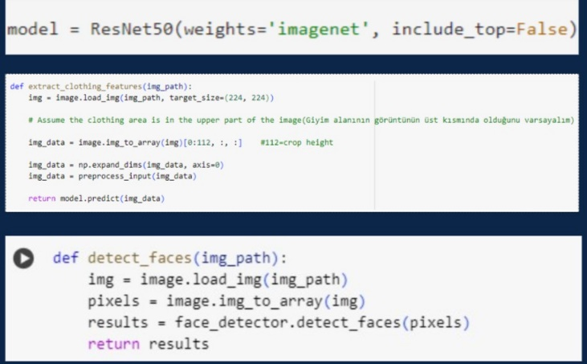

# METHOD

## Feature Extraction with ResNet50

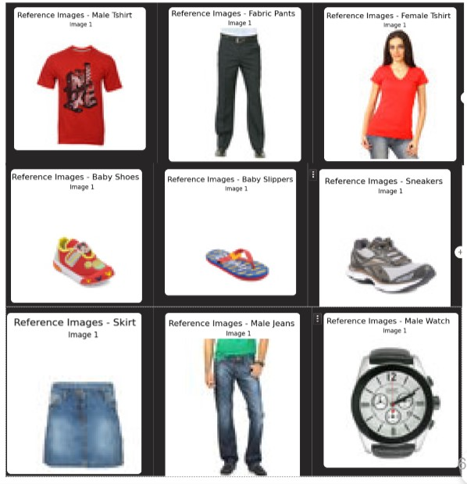It uses a pre-trained ResNet50 model for feature extraction from fashion images.

The model is loaded with pre-trained weights from the ImageNet dataset.

It extracts certain characteristics of clothes.

2.2 Face Detection with MTCNN

It uses the MTCNN (Multi-Task Cascaded Convolutional Networks) algorithm for face detection in images.

It ensures that images containing faces are removed from the recommendation process and only focuses on clothing items.

2.3 Cosine Similarity Calculation

It calculates the cosine similarity between features extracted from clothing items in input images and features of reference images for various clothing categories.

Similarity score is used to measure the similarity between input and reference images.

2.4 Display Screen

It uses Matplotlib to display reference images for different clothing categories, helping visualize the dataset.

2.5 Creating a Suggestion

For each clothing category, images in the specified directory are cycled through, except for those whose faces are detected.

Calculates the average cosine similarity between the features of the current image and the reference images for the relevant category.

It sorts the images in descending order based on their similarity scores and selects the best suggestions.

2.6 Displaying Top Recommendations

Prints the paths of the most recommended images along with their similarity ratios.

It uses Matplotlib to display the top recommended images for each clothing category.

2.7 Customization Support

We designed our code to be easily customizable, allowing users to expand the reference image dataset for each clothing category.

Users can adapt the recommendation system to various fashion areas by changing reference image paths and categories.

**3 REFERENCE IMAGES**

The system is trained on reference images representing various clothing categories, including male t-shirts, fabric pants, female t-shirts, baby shoes, baby slippers, sneakers, dress, short-sleeve shirt, female jeans, skirt, male jeans, male watch, hat, female watch, male shorts, and bag.

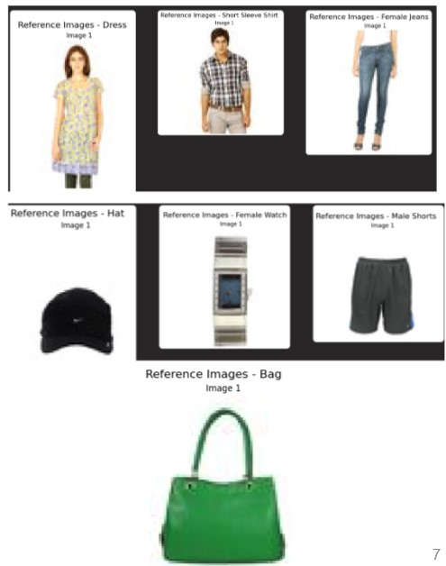

4 **RECOMMENDATION PROCESS**

The recommendation process involves calculating the cosine similarity between the features of a given image and the features of reference images for each clothing category. The top recommendations are then sorted based on similarity scores.

5 RESULTS and DISPLAYS

A deep learning architecture leveraging Convolutional Neural Networks (CNNs) was implemented to process paired images of pants and t-shirts. The model's architecture consisted of dual inputs for both clothing categories. The aim was to learn the relationship between different clothing combinations and corresponding user ratings.

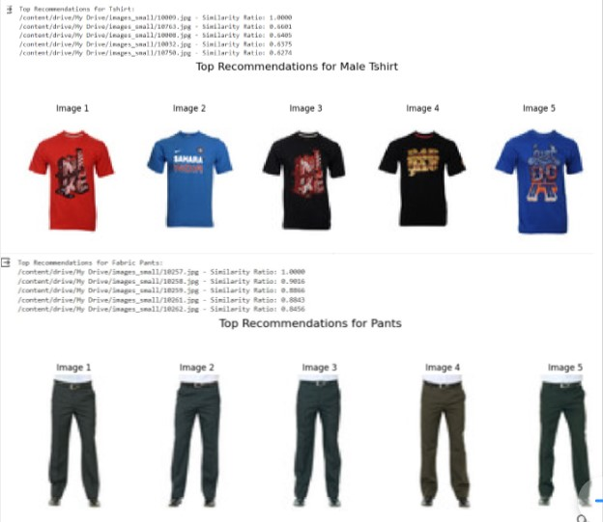

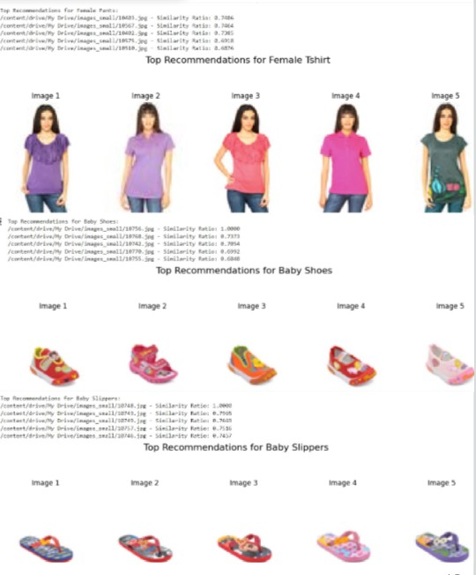

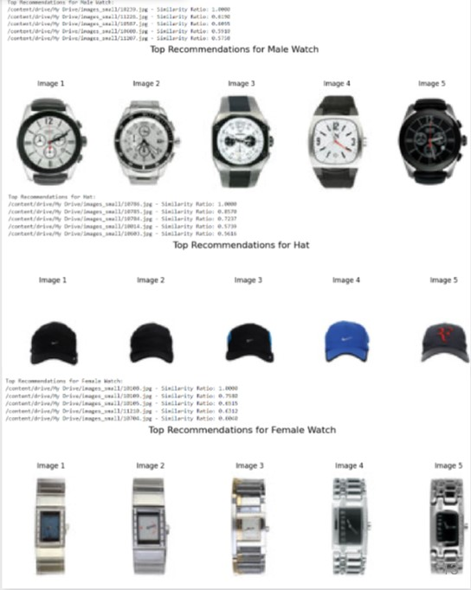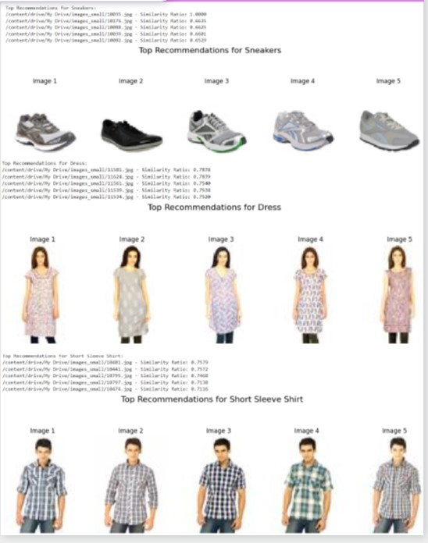

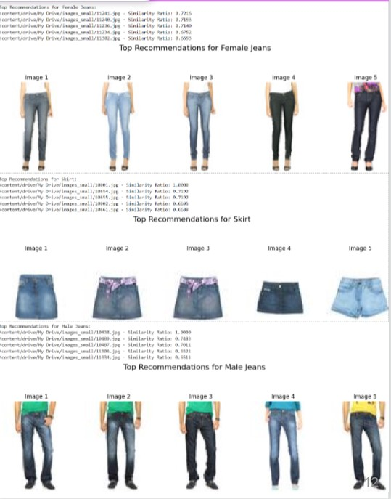

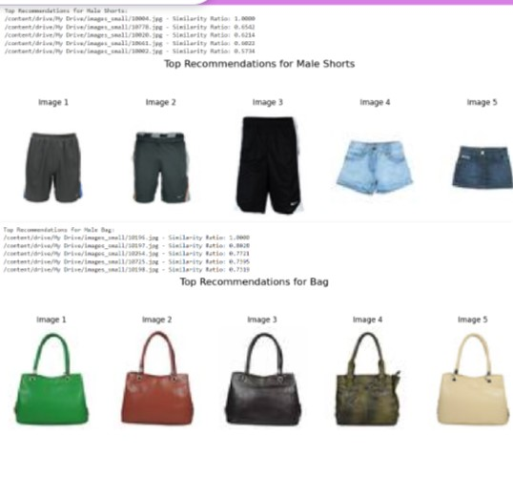

6 IMPROVEMENTS and FUTURE WORK

The system could benefit from user feedback and preferences to enhance personalization.

Experimenting with different pre-trained models and fine-tuning for specific clothing categories may improve performance

Handling multiple clothing items in a single image and providing ensemble recommendations could be explored.

7 CONCLUSION

• In summary, we present an outfit recommendation system implemented to demonstrate amazing capabilities resulting from the combination of deep learning methods and advanced similarity measurements. By seamlessly integrating these advanced technologies, the system expertly manages the complexities of fashion's visual environment and offers users a curated, personalized journey through a variety of clothing options.

• By successfully using a ResNet50 model pre-trained on ImageNet for feature extraction, we show that the system is capable of leveraging state-of-the-art neural network architectures. This choice not only reflects current advances in computer vision, but also provides a solid foundation for scalability and adaptability to evolving model architectures.

• By incorporating the MTCNN face detection algorithm, we use a subtle image preprocessing approach that recognizes the importance of excluding images containing faces in clothing recommendations. This thoughtful evaluation allows the system to focus solely on the visual characteristics of garments, thus increasing the accuracy and validity of its recommendations.

• As the system takes its place in the broader fashion recommendation landscape, it becomes a pioneering example of how AI is breaking traditional boundaries to deliver not just recommendations but also personalized experiences to users. The door is open for further development and improvement in this area; We invite research on the integration of user feedback, fine-tuning for specific clothing categories, and the potential integration of group recommendations.

• Essentially, our codebase not only offers a glimpse into the current state of fashion recommendation systems, but also lays the foundation for future innovations and we have fostered a continued evolution towards a more refined, intuitive and user-centered approach to online clothing recommendations. As the fashion tech landscape evolves, lessons learned from this exercise will undoubtedly contribute to the ongoing narrative of increasing user engagement and satisfaction in the space of online fashion platforms.g

with different pre-trained models

8 REFERENCES

• https://www.youtube.com/watch?v=xanJe6e8Xuw&t=3717s

• https://www.kaggle.com/datasets/paramaggarwal/fashion-product-images-small?select=images

• Shirkhani,

• S., Mokayed, H., Saini, R., & Hum, Y. C. (2023). Study of AI-Driven Fashion

• Recommender Systems. *SN Computer Science*, *4*(5). https://doi.org/10.1007/s42979-023-01932-9

• Chakraborty,

• S., Hoque, M. S., Jeem, N. R., Biswas, M. C., Bardhan, D., & Lobatón, E.

• (2021). Fashion Recommendation Systems, Models and Methods: a review. *Informatics*

• *(Basel)*, *8*(3), 49. https://doi.org/10.3390/informatics8030049

•Sridevi,

• M., ManikyaArun, N., Sheshikala, M., & Sudarshan, E. C. G. (2020).

• Personalized fashion recommender system with image based neural networks. *IOP*

• *Conference Series*, *981*, 022073. https://doi.org/10.1088/1757-899x/981/2/022073

• Chakraborty S, Hoque MS, Rahman Jeem N, Biswas

• MC, Bardhan D, Lobaton E. Fashion Recommendation Systems, Models and Methods: A

• Review. *Informatics*.